**Java Program to find the largest and smallest word in a string (input with in the program)**

**package**friday;

**publicclass**SmallestLargestWord{

**publicstaticvoid** main(String[] args){

String string = "Hardships often prepare ordinary people for an extraordinary destiny";

String word = "", small = "", large="";

String[] words = **new** String[100];

**int**length = 0;

//Add extra space after string to get the last word in the given string

string = string + " ";

**for**(**int**i = 0; i<string.length(); i++){

//Split the string into words

**if**(string.charAt(i) != ' '){

word = word + string.charAt(i);

}

**else**{

//Add word to array words

words[length] = word;

//Increment length

length++;

//Make word an empty string

word = "";

}

}

//Initialize small and large with first word in the string

small = large = words[0];

//Determine smallest and largest word in the string

**for**(**int**k = 0; k<length; k++){

//If length of small is greater than any word present in the string

//Store value of word into small

**if**(small.length() >words[k].length())

small = words[k];

//If length of large is less than any word present in the string

//Store value of word into large

**if**(large.length() <words[k].length())

large = words[k];

}

System.***out***.println("Smallest word: " + small);

System.***out***.println("Largest word: " + large);

} }

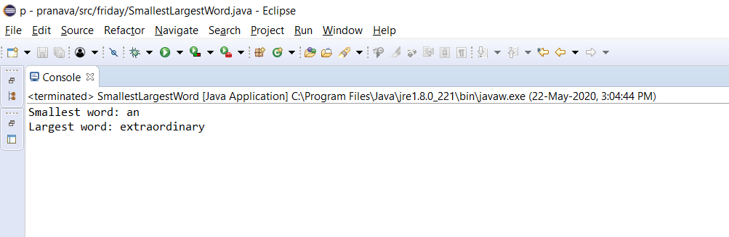**OUTPUT**

**Java Program to find the largest and smallest word in a string(input from the keyboard)**

**package**friday;

**import**java.io.BufferedReader;

**import**java.io.InputStreamReader;

**publicclass**LargestAndSmallestWord {

// Method to split the string and find the largest and smallest word

**staticvoid**printLargestAndSmallestWord(String str){

String[] arr=str.split(" ");

**int**i=0;

**int**maxlength,minlength;

maxlength=Integer.***MIN_VALUE***;

minlength=Integer.***MAX_VALUE***;

String largest,smallest;

largest = smallest = "";

**for**(i=0;i<arr.length;i++){

**if**(arr[i].length() <minlength){

smallest=arr[i];

minlength=arr[i].length();

}

**if**(arr[i].length() >maxlength) {

largest=arr[i];

maxlength=arr[i].length();

}

}

System.***out***.println("The largest and smallest word is: \"" + largest +

"\" and \"" + smallest + "\"");

}

// Main function to read the string

**publicstaticvoid** main(String[] args) {

BufferedReaderbr = **new**BufferedReader(**new**InputStreamReader(System.***in***));

System.***out***.println("Enter the text string");

String str;

**try**{

str=br.readLine();

}

**catch**(Exception e){

System.***out***.println("Error reading input");

**return**;

}

*printLargestAndSmallestWord*(str);

}

}

**OUTPUT**

